MongoDB and Node.js Project Report

Sahana Visarla

Disciple of Senior Developer Ariya Krishnan

September 24, 2023

**Table of Contents**

1. Introduction to Node.js
2. Modules in Node.js
3. Asynchronous Programming in Node.js
4. ES6 Concepts in Node.js
5. Introduction to MongoDB
6. Node.js and MongoDB Integration
7. Key Features of Node.js and MongoDB
8. Security in Node.js and MongoDB
9. Sample Project with CRUD Operations
10. Routes and Controllers for CRUD Operations
11. Creating Views for CRUD Operations
12. MongoDB Atlas
13. Connecting Node.js to MongoDB Atlas
14. MVC (Model-View-Controller) Architecture
15. Testing and Debugging
16. Deployment and Scaling
17. Performance Optimization for Node.js Applications
18. Conclusion
19. References and Used Tools

**Introduction to Node.js**

Node.js, originally created by Ryan Dahl in 2009, emerged as a groundbreaking technology that revolutionized server-side development. Its inception was motivated by the need for a more efficient and performant way to handle I/O operations in web applications. Traditional server-side technologies like Apache were ill-suited for handling numerous concurrent connections, often resulting in slow and inefficient performance. Node.js was conceived as a solution to these issues. Node.js boasts several key features that set it apart in the realm of server-side programming. One of its most significant features is its non-blocking I/O model. Unlike traditional synchronous server-side languages, Node.js operates on a non-blocking event loop. This means that instead of waiting for I/O operations to complete before moving on to the next task, Node.js can execute multiple tasks concurrently. As a result, it can handle a large number of simultaneous connections efficiently, making it ideal for building real-time and scalable applications. Another pivotal feature of Node.js is its event-driven architecture. In Node.js, events are used to trigger responses to various actions or occurrences. Developers can create event listeners that respond to specific events, enabling highly responsive and interactive applications. This event-driven approach is especially well-suited for building applications that require constant communication, such as chat applications or online gaming platforms.

To get started with Node.js, the first step is to install it on your system. Node.js comes with npm (Node Package Manager) bundled, making it convenient for managing packages and dependencies. You can download the Node.js installer from the official website (nodejs.org) and follow the installation instructions for your specific operating system. Once Node.js is installed, you can create a simple "Hello World" application to verify that everything is working correctly. Open a text editor and create a file named hello.js. In this file, you can write a basic Node.js script:

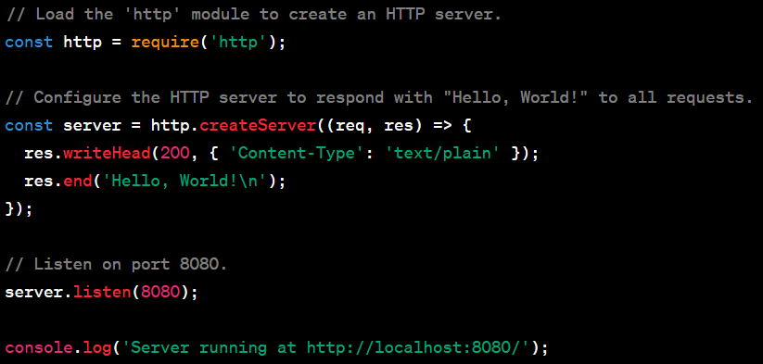

Save the file and open your terminal. Navigate to the directory containing hello.js and run the script using the following command:



You should see the message "Server running at http://localhost:8080/" in the terminal. This indicates that your Node.js server is running, and you can access it by opening a web browser and navigating to http://localhost:8080/. You'll see the "Hello, World!" message displayed in your browser.

This simple "Hello World" example demonstrates the fundamental concepts of Node.js, including loading modules, creating an HTTP server, and handling requests and responses. It serves as a foundational starting point for building more complex applications with Node.js.

**Modules in Node.js**

In Node.js, CommonJS modules are a fundamental concept that enables developers to organize their code into reusable and modular components. These modules facilitate the structuring of codebases, promote code reusability, and enhance maintainability. The system revolves around two core components: creating and using modules, and the require and module.exports statements. Creating modules in Node.js is straightforward. A module is essentially a JavaScript file containing functions, variables, or classes that you want to expose for use in other parts of your application. By encapsulating related code within a module, you ensure that it remains separate from the global scope and can be easily imported where needed. To create a module, you define the desired functionality within a JavaScript file. For example, you might create a module called math.js to handle mathematical operations. Inside math.js, you could define functions like add, subtract, multiply, and divide. Each of these functions becomes accessible to other parts of your application when you export them. The module.exports statement is used to make specific functions or objects from a module available for use in other parts of your application. In the case of our math.js module, you would export the functions like this:

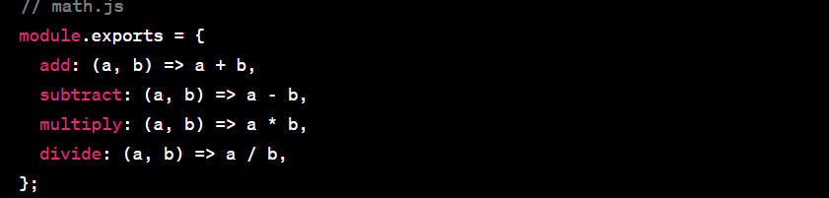

Once you've defined the module and exported its contents, you can use the require statement to import and use the module in other parts of your Node.js application. For example, if you have a main.js file where you want to use the math.js module, you would do the following:

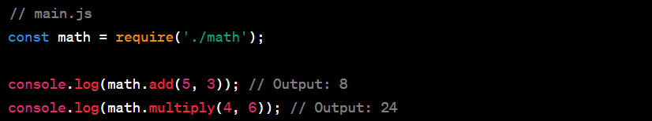

In this example, the require('./math') statement loads the math.js module, and you can then access its exported functions through the math object. CommonJS modules form the foundation of Node.js's modular architecture, allowing developers to structure their applications effectively and promote code reuse. The require and module.exports statements serve as the glue that connects these modules, making it easy to build complex, maintainable, and organized Node.js applications.

**Asynchronous Programming in Node.js**

Asynchronous programming is a fundamental concept in Node.js that enables developers to efficiently handle I/O operations and concurrency without blocking the main execution thread. This asynchronous nature is crucial for building responsive and performant applications. The key components of asynchronous programming in Node.js include the event loop, event-driven architecture, callbacks, promises, and the async/await syntax.

At the core of Node.js' asynchronous programming model is the event loop. The event loop is a single-threaded mechanism that continually checks for events and executes associated callbacks. It allows Node.js to perform tasks concurrently without blocking the execution of other code. When an asynchronous operation, such as reading a file or making an HTTP request, is initiated, Node.js registers a callback function to be executed once the operation is completed. The event loop ensures that these callbacks are called when the associated event occurs.

The event-driven architecture in Node.js is built around this event loop. It means that Node.js applications are designed to respond to events, such as incoming HTTP requests or data arriving from a database, rather than executing code sequentially. This architecture is well-suited for real-time applications, like chat applications, where responsiveness is crucial.

Callbacks are a foundational concept in asynchronous programming. They are functions that are passed as arguments to asynchronous functions. When the asynchronous operation is complete, the callback is invoked. Callbacks allow you to specify what should happen after an asynchronous operation finishes. However, they can lead to callback hell or "Pyramid of Doom" when multiple asynchronous operations are nested within each other.

Promises were introduced to mitigate the callback hell problem. A Promise is an object representing the eventual completion or failure of an asynchronous operation. It has methods like then and catch to handle success and error cases, making the code more readable and manageable. Promises also support chaining, allowing you to compose asynchronous operations sequentially.

The async/await syntax is a further improvement in handling asynchronous tasks. It's built on top of Promises and provides a more synchronous-like code structure while retaining the non-blocking nature of Node.js. With async/await, you can write asynchronous code that looks similar to traditional synchronous code, making it easier to reason about and maintain.

Here's an example of async/await in Node.js. In this code, await is used to pause the execution of the function until the asynchronous operation (fetching data from an API in this case) completes:

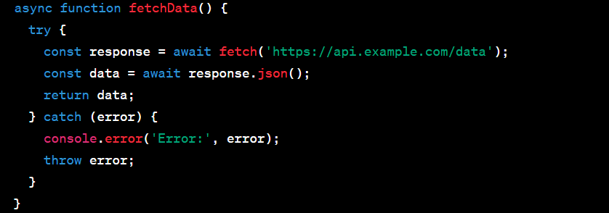

In conclusion, asynchronous programming, driven by the event loop and event-driven architecture, is a core aspect of Node.js that allows developers to build high-performance, non-blocking applications. Callbacks, promises, and async/await are tools that simplify the management of asynchronous tasks, making code more readable and maintainable while harnessing the power of Node.js's concurrency capabilities.

**ES6 Concepts in Node.js**

ES6 (ECMAScript 2015) introduced several important features that have become essential in Node.js development. Here's a concise overview of some of these features and how they are used in Node.js:

**Arrow Functions** - ES6 arrow functions provide a more concise syntax for defining functions. In Node.js, they are frequently used for defining callback functions and concise one-liners.

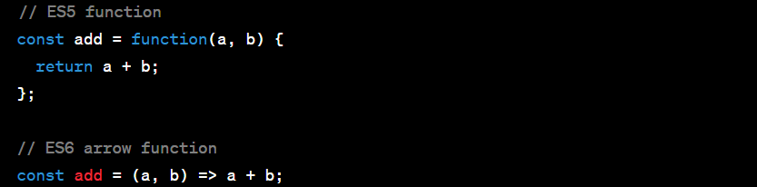

**Classes** - ES6 classes allow for object-oriented programming in Node.js. They are used to define constructors and methods for creating and manipulating objects, making code organization more straightforward.

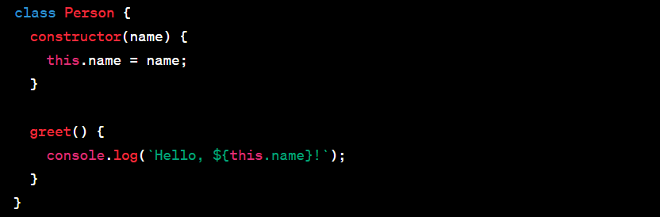

**Destructuring** - Destructuring simplifies the extraction of values from objects and arrays. In Node.js, it is employed for unpacking values, improving readability when working with complex data structures.



**Template Literals** - ES6 template literals allow for more dynamic string creation. In Node.js, they are used to embed variables and expressions within strings, enhancing string formatting.



**Let and Const** - ES6 introduced block-scoped variables with let and constants with const. These declarations are used to improve variable scoping and eliminate the issues associated with var.



These ES6 features have significantly improved the expressiveness, readability, and maintainability of Node.js code. By using arrow functions, classes, destructuring, template literals, and block-scoped variables, developers can write more modern and efficient server-side applications in Node.js.

**Introduction to MongoDB**

MongoDB, a popular NoSQL database, has transformed the database landscape with its flexibility and document-based storage model. This application was developed by a company called 10gen (now known as MongoDB, Inc.) and was first released in 2009. Its creation was driven by the need for a modern, flexible, and scalable database solution. MongoDB falls under the category of document-oriented databases. It is designed to store, retrieve, and manage data in a way that is particularly suited for applications with complex data structures and dynamic schemas.

— Here are some key features of MongoDB —

**Document-Based Storage** - MongoDB stores data in a format called BSON (Binary JSON). BSON is a binary-encoded serialization of JSON-like documents, making it easy to represent complex data structures, including nested arrays and objects, within a single document.

**Flexibility** - MongoDB's schema-less design allows developers to work with data in a more fluid manner. Unlike traditional relational databases, where schema changes can be complex and time-consuming, MongoDB lets you adapt your data model on-the-fly, making it suitable for agile development.

**Scalability -** MongoDB is inherently built to scale horizontally, meaning you can distribute data across multiple servers or clusters, providing high availability and load balancing. This makes it an ideal choice for large-scale applications.

**Ad Hoc Queries** - MongoDB supports rich query capabilities, enabling developers to search for data using a wide range of criteria. Queries can be written using a flexible and powerful query language.

**Indexes** - MongoDB supports the creation of indexes on fields, which significantly improves query performance. This is crucial when dealing with large datasets.

**High Performance** - MongoDB is known for its speed and efficiency in handling read and write operations. Its architecture and storage format are optimized for performance.

**Aggregation Framework** - MongoDB provides a powerful aggregation framework that allows you to perform complex data transformations and analytics directly within the database.

**Geospatial Features** -MongoDB includes support for geospatial queries, making it suitable for location-based applications.

To install MongoDB, you can visit the official MongoDB website (mongodb.com) and download the appropriate installer for your operating system. Follow the installation instructions provided for your platform.

— Here are some other features of MongoDB offers —

**MongoDB Compass GUI Too**l - MongoDB Compass is an official graphical user interface (GUI) tool provided by MongoDB, Inc. It simplifies database management and interaction. After installing MongoDB Compass, you can connect to your MongoDB server, view and manipulate data, create and manage indexes, and run ad hoc queries visually.

**MongoDB Community Edition** - MongoDB offers a free Community Edition that is suitable for many small to medium-sized projects. It includes the core features of MongoDB and is open-source.

**Enterprise Features** - For larger enterprises and organizations with advanced needs, MongoDB also provides a paid Enterprise Edition with additional features like enhanced security, monitoring, and support.

**Community and Ecosystem** - MongoDB has a vibrant and active community of developers and users. There are numerous third-party libraries, drivers, and plugins available for various programming languages and frameworks, making it easy to integrate MongoDB into your tech stack.

**Security** - MongoDB offers robust security features, including authentication mechanisms, encryption at rest and in transit, role-based access control, and auditing capabilities.

**Document Stores** - MongoDB is often referred to as a document store because it excels at managing collections of documents. Each document can have a different structure, making it versatile for a wide range of use cases.

**Use Cases** - MongoDB is suitable for a variety of use cases, including content management systems, e-commerce platforms, real-time analytics, Internet of Things (IoT) applications, and more.

**Backup and Restore** - MongoDB provides tools and mechanisms for backing up and restoring data, ensuring data reliability and recovery in case of failures.

**Community and Enterprise Support** - MongoDB has a strong commitment to supporting its users. The MongoDB community provides extensive documentation and forums, and enterprise customers have access to professional support and consulting services.

In summary, MongoDB is a flexible, document-oriented NoSQL database that offers features tailored for modern application development. Its ease of use, scalability, and rich feature set have made it a popular choice for a wide range of applications across various industries. Installing MongoDB and MongoDB Compass allows developers and administrators to harness the power of this database system for their projects.

**Node.js and MongoDB Integration**

Integrating MongoDB with Node.js using the MongoDB Node.js driver is a powerful combination for building data-driven applications. This integration enables seamless communication between your Node.js application and the MongoDB database. Here, we'll explore the process of connecting to a MongoDB database from a Node.js application and performing basic database operations such as insert, update, delete, and query. MongoDB provides an official Node.js driver that allows Node.js applications to interact with MongoDB databases. You can install this driver using npm. To establish a connection to a MongoDB database from your Node.js application, you typically use the mongodb library and its MongoClient class. You provide the connection string (URI) in this format:

mongodb://<username>:<password>@<host>:<port>/<database>.

The MongoDB Node.js driver includes built-in connection pooling, which manages and optimizes connections to the database. This ensures efficient resource utilization. You can insert documents into a MongoDB collection using the insertOne or insertMany methods. These methods accept JavaScript objects representing the data to be inserted. MongoDB supports various update operations. The updateOne and updateMany methods allow you to modify existing documents based on specified criteria. You can use $set, $unset, and other update operators to update specific fields within documents. To remove documents from a MongoDB collection, you can use the deleteOne or deleteMany methods, specifying the criteria for document deletion. MongoDB provides flexible querying options. You can use the find method to retrieve documents that match specific criteria. The query criteria are typically defined as JavaScript objects. MongoDB also supports sorting and pagination through options like sort, limit, and skip in query operations. This is especially useful for handling large datasets. You can specify which fields to include or exclude in query results using the projection option. This minimizes network and memory usage by returning only the necessary data. MongoDB offers an aggregation framework that allows you to perform complex data transformations, calculations, and grouping operations directly within the database, enhancing query capabilities.

When interacting with MongoDB, it's crucial to implement error handling to gracefully handle potential issues, such as network errors or duplicate key violations. You can use middleware libraries like Mongoose or native MongoDB middleware to simplify and structure your database interactions further. Mongoose, for instance, provides an Object Data Modeling (ODM) layer on top of MongoDB, which adds schema validation and other features. MongoDB allows you to create indexes on specific fields to improve query performance. You can create single-field or compound indexes to optimize queries. Ensure that you follow best practices for securing your MongoDB connection by using proper authentication and authorization mechanisms, and by setting up user roles with appropriate permissions. Implement robust error handling mechanisms in your Node.js application to gracefully handle database errors and exceptions. Thoroughly test your database operations to ensure data integrity and the reliability of your application. You can use testing frameworks like Mocha and Chai to automate testing. Incorporate logging into your application to track database interactions and diagnose issues during development and production. As your application grows, consider MongoDB's scalability options, including sharding, to distribute data across multiple servers or clusters for high availability and performance. Use monitoring tools and services to keep an eye on the performance and health of your MongoDB database, allowing you to proactively address potential bottlenecks or problems. MongoDB offers extensive documentation and has a vibrant community that can provide support and guidance when working with Node.js and MongoDB integration.

In summary, integrating MongoDB with Node.js using the MongoDB Node.js driver empowers developers to build robust, data-driven applications. By connecting to MongoDB, performing essential database operations, and applying best practices, you can create efficient and reliable applications that harness the power of NoSQL databases for storage and retrieval of data.

**Key Features of Node.js and MongoDB**

Node.js and MongoDB are integral components of modern web development, providing the efficiency, scalability, and flexibility necessary to build high-performance, real-time, and data-rich web applications that meet the demands of today's users and businesses. Their continued growth and adoption signify their enduring importance in the evolving web development landscape.

**Scalability** — Node.js is renowned for its non-blocking, event-driven architecture, making it ideal for building highly scalable and real-time web applications that can handle a large number of concurrent connections.

**Efficiency** — Node.js enables developers to use JavaScript for both client and server-side development, streamlining the development process and reducing the need for context switching.

**Cross-Platform Compatibility** — Node.js is cross-platform, allowing developers to write code that works seamlessly on various operating systems, enhancing code reusability and reducing development time.

**Vibrant Ecosystem** — The Node.js ecosystem boasts a vast collection of open-source libraries and packages available via npm, making it convenient to integrate third-party tools and modules into applications.

**Fast Execution** — Node.js leverages the V8 JavaScript engine, known for its speed and efficiency, ensuring rapid execution of code and quick response times for web applications.

**Real-Time Web Applications** — Node.js excels at building real-time applications like chat applications and online gaming platforms, where low latency and constant communication are crucial.

**MongoDB's Flexibility** — MongoDB, a NoSQL database, offers flexibility in data modeling, allowing developers to store unstructured or semi-structured data, which is especially useful in dynamic web applications.

**Horizontal Scaling** — MongoDB's ability to horizontally scale databases across multiple servers ensures that applications can handle increased loads as user bases grow.

**Ease of Development** — MongoDB's document-oriented data model closely resembles JSON, simplifying the development process by reducing the impedance mismatch between the application code and the database.

**Rich Data Access** — The combination of Node.js and MongoDB provides developers with a powerful toolset for working with data, offering the flexibility to perform complex queries and efficiently retrieve, manipulate, and store data in modern web applications.

**Security in Node.js and MongoDB**

Security is a paramount concern when developing applications with Node.js and MongoDB. To ensure the safety of your application and data, it's crucial to follow common security best practices. In Node.js, this includes using packages with a strong security track record, regularly updating dependencies to patch vulnerabilities, implementing authentication and authorization mechanisms, and validating and sanitizing user inputs to prevent injection attacks like SQL and NoSQL injection. For MongoDB, securing your database involves configuring access controls, enabling authentication, and restricting network access to trusted IPs. Additionally, encryption of data both in transit and at rest should be employed. To guard against common vulnerabilities like Cross-Site Scripting (XSS), Cross-Site Request Forgery (CSRF), and insecure deserialization, consider using security libraries and frameworks like Helmet for Node.js and implementing security headers. Regular security audits and code reviews are also essential to identify and mitigate potential risks. By adopting these security practices, you can significantly enhance the protection of your Node.js and MongoDB-based applications against a wide range of threats.

**Sample Project with CRUD Operations**

Building a sample project that demonstrates CRUD (Create, Read, Update, Delete) operations is a great way to understand how data manipulation works in web applications. In this example, let's create a simple To-Do List application using Node.js and MongoDB as the backend database. The To-Do List application will allow users to create, read, update, and delete tasks. Each task will have a title, description, and status (e.g., "In Progress," "Completed"). We'll start by setting up the project structure.

Project Structure:

* Create a new directory for your project (e.g., todo-app) and navigate into it.
* Initialize a Node.js project using npm init.
* Install necessary packages: express for the web server, mongoose for MongoDB interaction, and ejs for rendering views.
* Create folders for routes, models, views, and public assets (CSS, JavaScript).
* Set up your project's entry point (e.g., app.js), and create the basic structure of your Express application.

Now, let's implement each CRUD operation:

1. Create (Adding a Task) — To add a task, create a POST route that accepts form data from the user. Use the Task model (which you'll define later) to create and save the new task in the database.

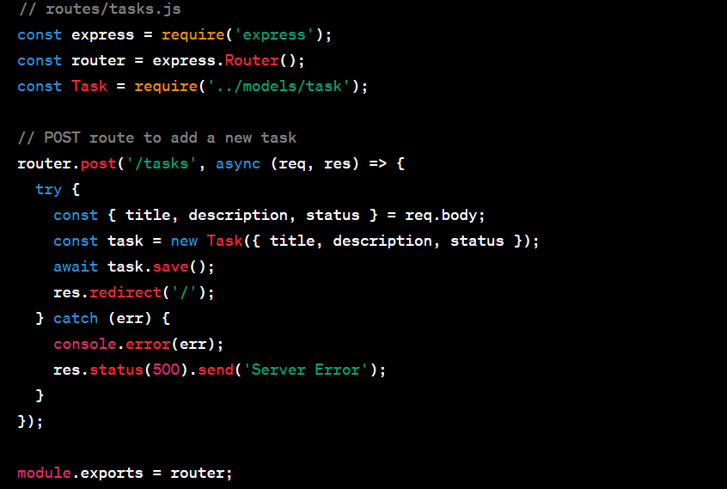

2. Read (Displaying Tasks) — To display tasks, create a GET route that fetches all tasks from the database using the Task.find() method.

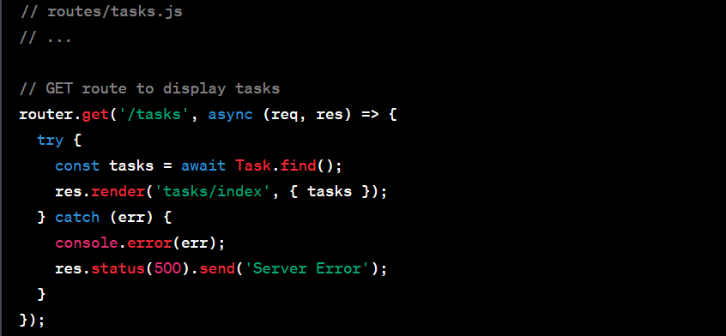

3. Update (Editing a Task) — To edit a task, create a route that allows users to access a task's details and update them. Use the Task.findById() method to retrieve the task’s unique ID and save changes.

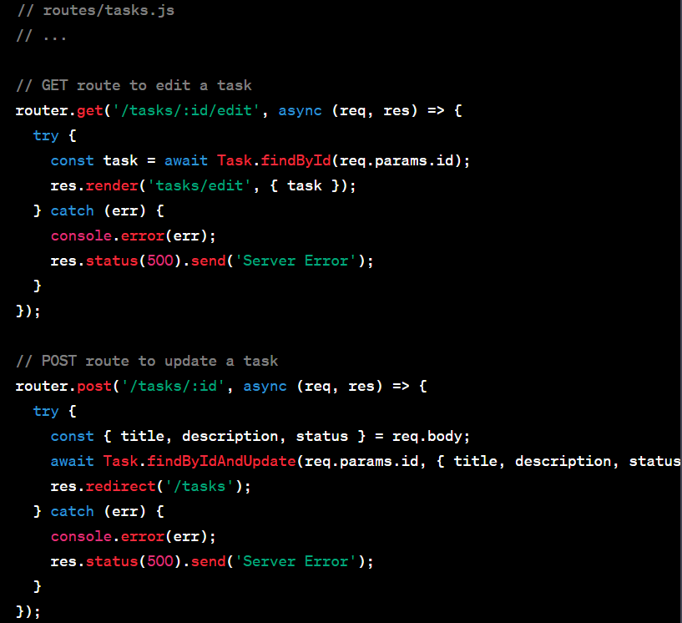

4. Delete (Removing a Task):

To delete a task, create a DELETE route that removes the task from the database using the Task.findByIdAndRemove() method.

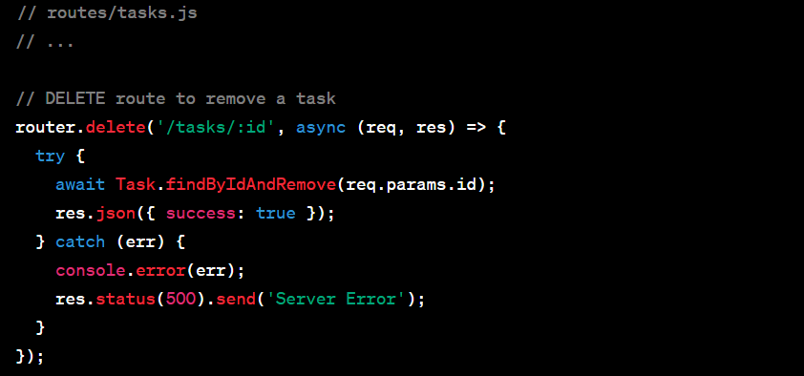

By implementing these CRUD operations, your To-Do List application allows users to create, read, update, and delete tasks. You can further enhance the project by adding user authentication, validation, and more features as needed. This example demonstrates how to build a basic web application with Node.js, MongoDB, and Express.

**Routes and Controllers for CRUD Operations**

Creating routes and controllers is a fundamental aspect of building web applications, especially when following the Model-View-Controller (MVC) architecture. Routes define the URL endpoints that correspond to different actions, while controllers handle the business logic associated with these actions. Here's a step-by-step guide on how to create routes and controllers for various CRUD (Create, Read, Update, Delete) operations in a web application:

1. Project Structure: First, ensure you have a well-organized project structure. Commonly, you'd have folders for routes, controllers, models (if applicable), views, and other assets.
2. Initialize Express: In a Node.js application, initialize Express, a popular web framework. Import it and create an instance of the app:



1. Defining Routes: Set up routes for different CRUD operations. Routes are defined using Express's app object. Here's how you define a simple route:

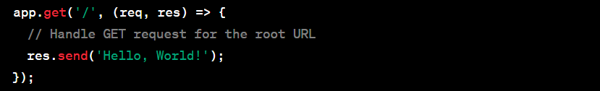

1. Route Parameters: For dynamic routes, you can define parameters using colon notation. These parameters can be accessed in the controller function:

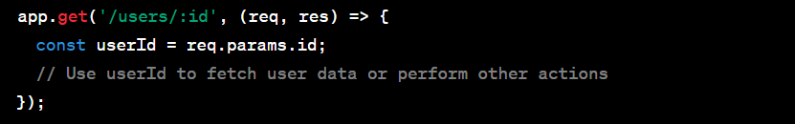

1. Route Handling: Create separate route files for better code organization. For instance, you can create a users.js file in the routes folder and define user-related routes there.
2. Controller Functions: In the controller file (e.g., users.js), export functions to handle CRUD operations. These functions will be responsible for interacting with data, performing business logic, and responding to client requests. For example:

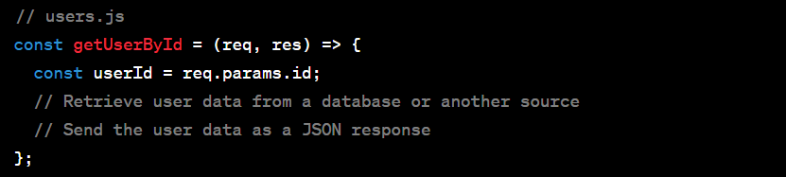

1. Linking Routes to Controllers: Import the controller functions into your route file and link them to specific routes. Use app.get(), app.post(), app.put(), and app.delete() for the respective HTTP methods:

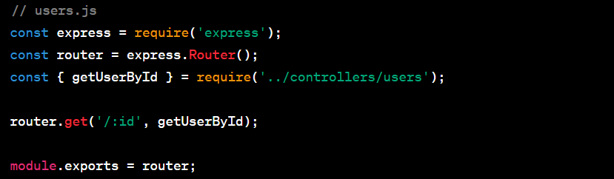

1. Use Route Middleware: You can also use route-specific middleware functions to perform tasks like data validation, authentication, or logging before reaching the controller:

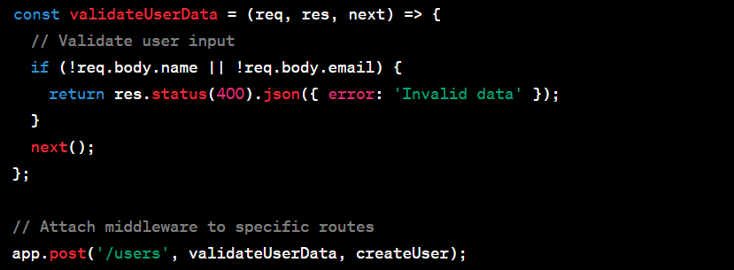

1. Error Handling: Implement error handling within controllers and route middleware to gracefully handle exceptions and provide appropriate responses to clients.
2. Testing Routes and Controllers: Thoroughly test your routes and controller functions using testing frameworks like Mocha, Chai, or Jest. Automated testing ensures that your routes and controllers work as expected.

By following these steps, you can effectively create routes and controllers in your web application, allowing you to define endpoints for different CRUD operations, implement the associated business logic, and maintain a clean and organized codebase. This separation of concerns improves code readability, reusability, and scalability in your application.

**Creating Views for CRUD Operations**

Creating views in a web application is crucial for presenting data to users in a user-friendly and visually appealing manner. Template engines are tools that facilitate dynamic content generation by allowing developers to embed server-side code within HTML templates. These engines help separate the presentation layer (views) from the business logic (controllers). Information regarding engines like EJS (Embedded JavaScript) or Pug (formerly known as Jade) and guidance on creating views for a CRUD (Create, Read, Update, Delete) application will be provided in this section. Start by installing the template engine of your choice using npm. For example, to install EJS, run:



Then, set up Express to use the template engine in your app configuration:

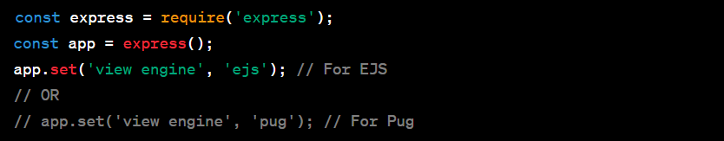

Create a directory (e.g., views) in your project to store your view templates. Views typically have the file extension .ejs for EJS or .pug for Pug. Many web applications use a layout template to define the overall structure of pages (header, footer, navigation, etc.). Create a layout template (e.g., layout.ejs) that includes placeholders for dynamic content:

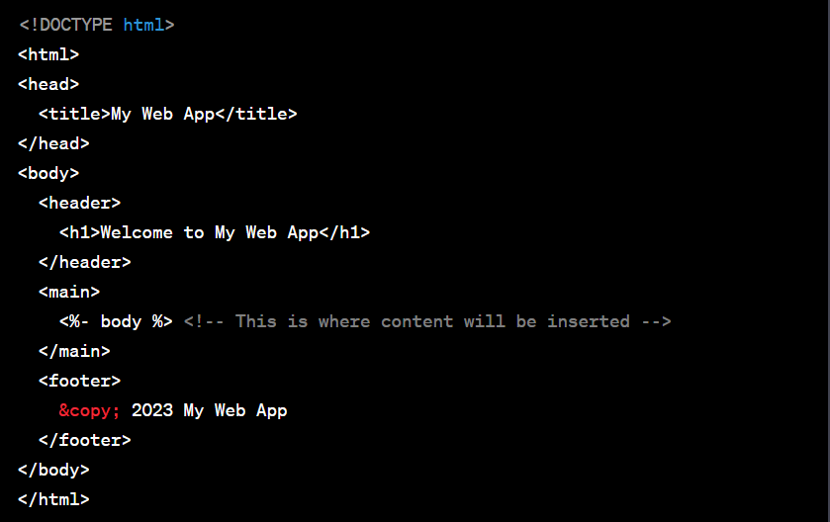

In your Express routes, use the res.render() method to render views. Pass data (variables) that you want to display in the view as an object:

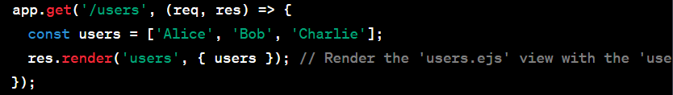

Create view templates for each route or page in your application, extending the layout template as needed. In the views directory, create files like users.ejs or index.ejs:

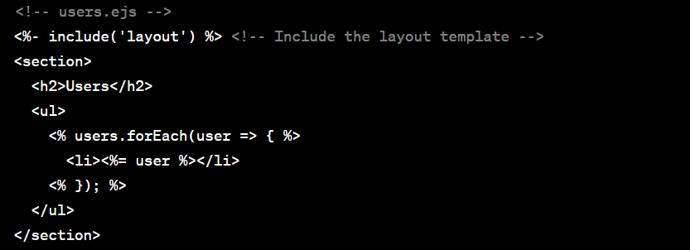

Use template engine tags (e.g., <%= %>) to insert dynamic data into your views. These tags allow you to interpolate server-side data into your HTML templates. Template engines often support partials or includes, allowing you to reuse components across multiple views. In the example above, we used <%- include('layout') %> to include the layout template. Implement error handling in your views to gracefully handle exceptions and display error messages to users when necessary. Test your views thoroughly to ensure that they render correctly and display the expected data. Automated testing can help identify rendering issues.

By following these steps and using a template engine like EJS or Pug, you can create views that enhance the user experience of your CRUD application. Template engines simplify the process of generating dynamic HTML content, making it easier to build and maintain the presentation layer of your web application while keeping it separate from the application's logic.

**MongoDB Atlas**

MongoDB Atlas is a cloud-based database service offered by MongoDB, Inc., designed to simplify database management and provide a scalable, reliable, and secure platform for hosting MongoDB databases.This is a fully managed database service, meaning that MongoDB, Inc. takes care of the administrative tasks such as database setup, maintenance, scaling, and backups, allowing developers to focus on building their applications. It offers a wealth of benefits to developers and organizations looking to leverage MongoDB in their applications.

There are many benefits that MongoDB Atlas provides. MongoDB Atlas handles routine database management tasks, including patching, upgrades, and scaling, reducing operational overhead. It offers built-in high availability with automatic failover, ensuring minimal downtime in case of hardware or network failures. MongoDB Atlas allows you to easily scale your database vertically (by changing resource allocation) or horizontally (by adding more nodes) to accommodate changing workloads. It provides robust security features, including network isolation, encryption at rest and in transit, role-based access control, and IP whitelisting. Automatic daily backups and point-in-time recovery options help protect your data from accidental deletions or data corruption. MongoDB Atlas offers real-time performance monitoring and alerting, giving insights into the health and performance of your database. You can choose from multiple cloud providers and regions to deploy your MongoDB Atlas clusters closer to your end-users for low-latency access. It integrates seamlessly with popular cloud services and platforms, like AWS, Azure, and Google Cloud, as well as other MongoDB tools and services.

Setting Up a Free Atlas Cluster:

* To get started with MongoDB Atlas, visit the official MongoDB website and sign up for an Atlas account.
* After registration, log in to your Atlas account and click "Build a New Cluster."
* Choose a cloud provider (e.g., AWS, Azure, or Google Cloud), select a region for your cluster, and choose a cluster tier (you can start with the free tier called M0).
* Configure additional cluster settings, such as backup options, and define cluster and database names.
* Click "Create Cluster" to initiate the cluster creation process.
* Once the cluster is provisioned, you can access it through the MongoDB Atlas dashboard, where you can manage and monitor your databases.

In conclusion, MongoDB Atlas is a user-friendly and powerful platform for hosting MongoDB databases in the cloud. It offers numerous advantages, including automated management, high availability, scalability, security, and global deployment options. Setting up a free Atlas cluster is straightforward and provides an excellent opportunity to explore and experience the benefits of this managed database service without incurring initial costs.

**Connecting Node.js to MongoDB Atlas**

Connecting a Node.js application to MongoDB Atlas involves configuring your application to use the MongoDB Node.js driver and handling connection strings, which may contain sensitive information such as your Atlas credentials. Here's a step-by-step guide on how to do this while keeping your credentials secure using environment variables:

Install Dependencies: In your Node.js project, ensure that you have the mongodb driver installed. You can add it using npm:



Before connecting, set up a MongoDB Atlas cluster. You can sign up for a free account on the MongoDB Atlas website and create a cluster in your preferred region. In the Atlas dashboard, configure your cluster's network settings to allow your Node.js application to access it. You can either whitelist your IP address or set up a more secure connection via IP whitelisting with a VPC Peering or using a Private IP. Create a MongoDB Atlas database user with appropriate permissions for your application. Note down the username and password for this user. MongoDB Atlas provides a connection string that you can use to connect to your cluster. This connection string contains the credentials and other configuration details required for the connection.It's essential to keep sensitive information like connection strings and credentials out of your codebase to enhance security and facilitate configuration management. To do this, use environment variables.

Create a .env file in your project's root directory to store your environment variables. Add your MongoDB Atlas connection string to the .env file, like this:



Ensure your .env file is listed in your .gitignore file to prevent accidentally exposing sensitive information in version control. Use the dotenv Module: Install the dotenv module using npm to read the environment variables from your .env file:



In your Node.js application, load the environment variables using dotenv. Add the following code near the top of your main application file (e.g., app.js):



Access MongoDB connection string from the environment variables in your code:



Use the MongoDB Node.js driver to connect to MongoDB Atlas using the connection string from the environment variables:

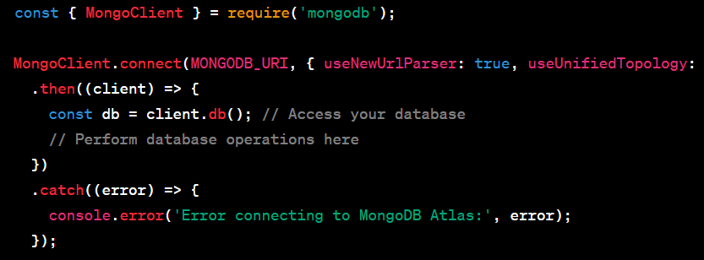

By following these steps, you can securely connect your Node.js application to MongoDB Atlas while keeping sensitive information safe in environment variables. This approach not only enhances security but also simplifies configuration management and deployment, making your application more maintainable and adaptable.

**MVC (Model-View-Controller) Architecture**

The Model-View-Controller (MVC) architecture is a widely adopted software design pattern used to organize code and separate concerns in web development. It promotes modularity, maintainability, and scalability by dividing an application into three interconnected components: the Model, the View, and the Controller. MVC stands for Model-View-Controller, where each component has a specific role in the application. In Node.js, implementing MVC helps separate different concerns within the application

Overview of MVC in Web Development:

* “Model” represents the data and business logic of the application. It interacts with the database, processes data, and performs validation.
* “View” deals with the presentation layer and user interface. It's responsible for displaying data and receiving user input.
* “Controller” acts as an intermediary between the Model and the View. It receives user requests, processes them, interacts with the Model to fetch or update data, and then renders the appropriate View.

Separation of Concerns in Node.js Applications:

* “Model” often includes data access and manipulation code. This is where you interact with databases like MongoDB using models.
* “View”, in the context of Node.js, often corresponds to the HTML templates or client-side rendering components that generate the user interface.
* “Controllers” in Node.js applications handle routing and request processing. They decide which Model methods to call and which View templates to render based on user requests.

Role of MongoDB Models in MVC:

MongoDB Models play a role in MVC. In an MVC Node.js application with MongoDB, the Model component includes defining schemas using a library like Mongoose. Schemas define the structure of documents to be stored in the MongoDB database. MongoDB models encapsulate database operations. They provide an abstraction layer for creating, reading, updating, and deleting documents, making it easier to work with the database. Models can also include data validation logic. You can define rules for data validation within the Model to ensure that only valid data is stored in the database. Complex business logic can reside within the Model. This ensures that application-specific rules and calculations are contained within the appropriate component. By using the MVC architecture in a Node.js application with MongoDB, you can maintain a clear separation of concerns, making it easier to manage, test, and scale your codebase. MongoDB models play a crucial role in this architecture by handling data access and manipulation, database interactions, and data validation within the Model component, while the Controller manages the flow of data and the View handles the presentation layer. This modular and organized structure enhances the overall maintainability and efficiency of your web application.

**Testing and Debugging**

Testing and debugging are essential practices in Node.js application development to ensure code quality, identify and fix issues, and maintain a reliable and robust software system.

Writing Unit Tests for Node.js Applications:

1. **Choose a Testing Framework** — Start by selecting a testing framework like Mocha, Jest, or Jasmine. These frameworks provide a structured environment for writing and running tests.
2. **Create Test Files** — Organize your tests into separate files that mirror the structure of your application code. For example, if you have a user.js module, create a corresponding user.test.js file for tests.
3. **Write Test Suites and Cases** — Use the testing framework's syntax to define test suites and individual test cases. Describe the expected behavior of your code in these tests.
4. **Mock Dependencies** — In unit testing, isolate the code you're testing from external dependencies by using mocking libraries like Sinon or Jest's built-in mocking capabilities.
5. **Execute Tests** — Run your tests using the testing framework's command-line tools or npm scripts. For instance, if you're using Mocha, run mocha or npm test.
6. **Assertions** — Use assertion libraries like Chai or Jest's built-in assertions to check if the actual output matches the expected output in your test cases.
7. **Continuous Integration** — Integrate your tests into your Continuous Integration (CI) pipeline to automatically run tests whenever code changes are pushed to version control.

Debugging Node.js Applications using VSCode and the Node.js Debugger

1. **Use a Code Editor** —Install a code editor like Visual Studio Code (VSCode) that supports debugging Node.js applications.
2. **Set Breakpoints** — Place breakpoints in your code by clicking in the left margin of the editor or using VSCode's keyboard shortcuts. Breakpoints stop the execution of your code at specific lines.
3. **Launch Configuration** — Create a launch configuration in VSCode for your Node.js application. This configuration specifies the entry point of your application and how it should be debugged.
4. **Start Debugging** — Start your application in debugging mode by running it using the launch configuration you've created. The code will execute until it encounters a breakpoint.
5. **Inspect Variables** — While debugging, you can inspect variables, view call stacks, and evaluate expressions in real-time using VSCode's debugging sidebar.
6. **Stepping Through Code** — Use the step over, step into, and step out of functions to navigate through your code one step at a time. This helps you trace the flow of execution.
7. **Debug Console** — The VSCode debug console allows you to interactively execute JavaScript code in the context of your application while debugging.
8. **Watch Expressions** — Set up watch expressions to monitor the values of specific variables as your code runs. This helps you track how values change during execution.
9. **Handling Exceptions** — VSCode automatically breaks on unhandled exceptions, making it easier to identify and fix errors in your code.
10. **Node.js Debugger** — If you prefer a command-line approach, Node.js comes with a built-in debugger. You can run your script with node inspect or node --inspect and then use the debugger commands to control execution.

By following these testing and debugging practices, you can significantly improve the quality and reliability of your Node.js applications. Writing unit tests helps catch issues early in the development process, while debugging tools like VSCode and the Node.js debugger provide powerful ways to pinpoint and resolve problems in your code efficiently.

**Deployment and Scaling**

Deployment and scaling are critical phases in the lifecycle of a Node.js application, ensuring that it's accessible, performant, and can handle increased traffic.

Preparing the Application for Deployment:

Before deployment, optimize your Node.js code for performance. Minimize resource-intensive operations and ensure efficient use of CPU and memory. Use environment variables for sensitive information like API keys, database credentials, and configuration settings. This keeps sensitive data secure and allows you to configure your app differently for various environments (development, staging, production). Implement configuration management to handle environment-specific settings. Libraries like dotenv can load environment variables from a .env file. If your application serves static assets like images, stylesheets, or JavaScript files, consider using a CDN (Content Delivery Network) for efficient content distribution. Optimize database queries and indexing to ensure efficient data retrieval and storage. Implement comprehensive logging to track errors, performance metrics, and application events. Tools like Winston or Morgan can help with this. Implement error handling middleware to gracefully handle exceptions and provide meaningful error responses to clients.

Options for Deploying Node.js Applications:

**Heroku** — Heroku is a popular Platform-as-a-Service (PaaS) that simplifies deployment. You can deploy Node.js applications by pushing your code to a Heroku Git repository or using containerization with Docker. Heroku handles server provisioning, scaling, and maintenance.

**AWS Elastic Beanstalk** — AWS Elastic Beanstalk provides an easy way to deploy and manage applications on AWS. It supports Node.js applications and offers automatic scaling, load balancing, and monitoring.

**AWS Lambda** — For serverless deployment, AWS Lambda allows you to run Node.js functions in response to events. It automatically scales based on demand and bills you only for the compute time used.

**Docker and Kubernetes** — Containerization with Docker and orchestration with Kubernetes provide flexibility and scalability. You can deploy Node.js applications as Docker containers and manage them using Kubernetes for container orchestration.

**Nginx or Apache** — Deploying behind an Nginx or Apache web server is a common approach. These web servers can serve static files, handle SSL termination, and act as reverse proxies for your Node.js application.

**Serverless Framework** — The Serverless Framework simplifies deploying serverless applications, including Node.js functions, to various cloud providers like AWS, Azure, Google Cloud, and more.

**Self-Managed Servers** — If you prefer more control, you can deploy Node.js applications on virtual private servers (VPS) from providers like AWS EC2, DigitalOcean, or Linode. This approach gives you full control over the server configuration but requires more maintenance.

**PaaS Providers** — Other PaaS providers like Google App Engine, Microsoft Azure App Service, and IBM Cloud Foundry also support Node.js applications and offer deployment and scaling features.

Continuous Integration and Continuous Deployment (CI/CD) — Implement CI/CD pipelines using tools like Jenkins, Travis CI, CircleCI, or GitHub Actions to automate the deployment process whenever new code is pushed to the repository.

**Monitoring and Scaling** — Regardless of the deployment choice, implement monitoring and scaling strategies to ensure your application can handle increased traffic. Utilize cloud providers' scaling options or tools like Kubernetes Horizontal Pod Autoscaling.

The choice of deployment platform depends on your specific requirements, scalability needs, and familiarity with the platform's tools and services. Each option offers its own set of advantages and trade-offs, so consider your project's constraints and goals when making a decision.

**Performance Optimization for Node.js Applications**

Optimizing the performance of Node.js applications is crucial to ensure they are responsive and efficient, especially in high-traffic scenarios. Several strategies can be employed to achieve this.

Implementing caching mechanisms can significantly boost the performance of Node.js applications. By caching frequently accessed data, such as database query results or API responses, you reduce the need to recompute or fetch data from external sources, thus reducing latency. Popular caching solutions for Node.js include in-memory caches like Redis or Memcached, which store key-value pairs and allow for quick data retrieval. You can also utilize HTTP caching headers to cache static assets in the client's browser, further reducing the load on the server.

Load balancing distributes incoming requests across multiple server instances, ensuring that no single server becomes a bottleneck. Node.js applications can benefit from load balancing, especially in scenarios where horizontal scaling is required. Tools like Nginx or application-specific load balancers can be used to evenly distribute traffic across Node.js instances. Load balancing helps maximize resource utilization, improves response times, and enhances application reliability by preventing overloads on individual servers. Additionally, it enables easy scaling up or down to accommodate varying levels of traffic.

Node.js is built around asynchronous, non-blocking I/O, and mastering asynchronous programming techniques is crucial for optimal performance. Utilize callbacks, Promises, or async/await to manage concurrency effectively. Employing asynchronous techniques prevents blocking operations, enabling your application to handle multiple requests concurrently. Additionally, consider using the Node.js Event Loop efficiently to minimize idle times and maximize the utilization of CPU cores. Profiling and performance monitoring tools like Node.js's built-in perf_hooks or third-party tools like New Relic can help identify performance bottlenecks and areas for improvement in your application's asynchronous code. By combining caching, load balancing, and skillful use of asynchronous programming, you can significantly enhance the performance and scalability of your Node.js applications, ensuring they can handle high loads and deliver responsive user experiences.

**Conclusion**

In conclusion, the integration of Node.js and MongoDB has ushered in a transformative era in web development and database management. These two technologies have brought forth several key takeaways that underscore their significance in the present and future of software development.

Firstly, the non-blocking I/O capability of Node.js has revolutionized the way we build real-time applications and microservices, allowing for efficient handling of concurrent connections. This asynchronous nature of Node.js not only enhances performance but also aligns seamlessly with MongoDB's document-based storage and JavaScript-based ecosystem, making full-stack development a cohesive and streamlined experience. Flexibility is a cornerstone of MongoDB's design, as it supports dynamic schemas, enabling developers to adapt to evolving requirements without the constraints of rigid data structures. Moreover, the JSON-like documents used in MongoDB facilitate smooth data exchange with Node.js applications, simplifying data manipulation and serialization. Scalability is another hallmark of Node.js and MongoDB integration. Node.js can effectively manage a high volume of connections, while MongoDB's horizontal scaling capabilities enable the efficient distribution of data across clusters, catering to applications of varying sizes and demands. Real-time applications, such as chat platforms, gaming environments, and IoT systems, greatly benefit from this integration due to Node.js's event-driven architecture and MongoDB's support for real-time data updates. Both technologies share vibrant open-source communities, contributing to their continuous enhancement and the availability of extensive libraries and plugins.

Looking ahead, future developments in Node.js and MongoDB integration are poised to be transformative. Performance enhancements will continue to be a focus, with optimizations tailored for multi-core processors and large-scale deployments. The adoption of GraphQL as an alternative to REST APIs may rise, with support from both Node.js and MongoDB. Serverless computing and Function-as-a-Service (FaaS) platforms will deepen their integration with Node.js, offering resource efficiency and cost savings. AI and machine learning applications are expected to thrive within this ecosystem, leveraging the robust data processing capabilities of MongoDB and the event-driven nature of Node.js. Security remains paramount, prompting ongoing updates and features to fortify data protection and authentication mechanisms. Compliance with data privacy regulations, exemplified by GDPR, will become increasingly pivotal, with features and tools developed to facilitate adherence.

The significance of Node.js and MongoDB integration lies in their empowerment of developers to create high-performance, scalable, and real-time applications with remarkable efficiency. This pairing epitomizes flexibility, speed, and a streamlined development life cycle. As we gaze into the future, Node.js and MongoDB will undoubtedly play a pivotal role in shaping the landscape of modern web and application development. Their synergy is poised to fuel innovation and enable businesses to meet the dynamic demands of our digitally driven world, where real-time communication, scalability, and flexibility are not just desirable but essential attributes of success.

**References and Used Tools**

<https://nodejs.dev/en/learn/>

<https://www.youtube.com/watch?v=00nHyY-r5e0>

<https://www.youtube.com/watch?v=TlB_eWDSMt4>

<https://www.mongodb.com/docs/manual/introduction/>

<https://www.tutorialspoint.com/expressjs/expressjs_restful_apis.htm>

<https://www.freecodecamp.org/news/what-is-npm-a-node-package-manager-tutorial-for-beginners/>